GET GST DETAILS AUTOMATICALLY.

# GETTING DETAILS IN EXCEL:

First press windows button and type JUPYTER NOTEBOOK

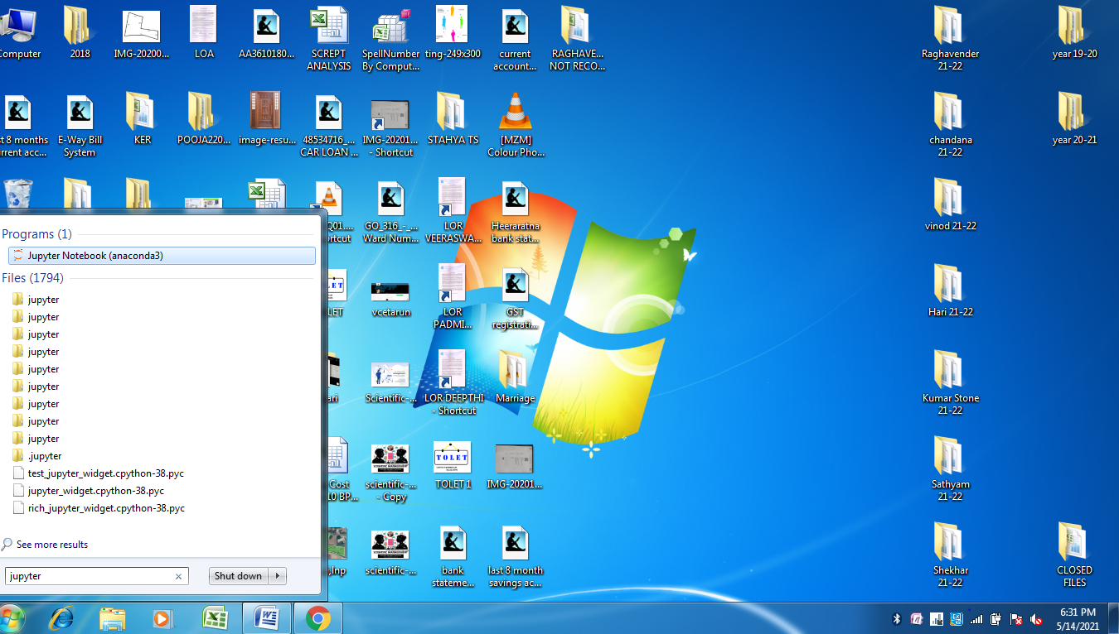

Click on jupyter notebook and it opens as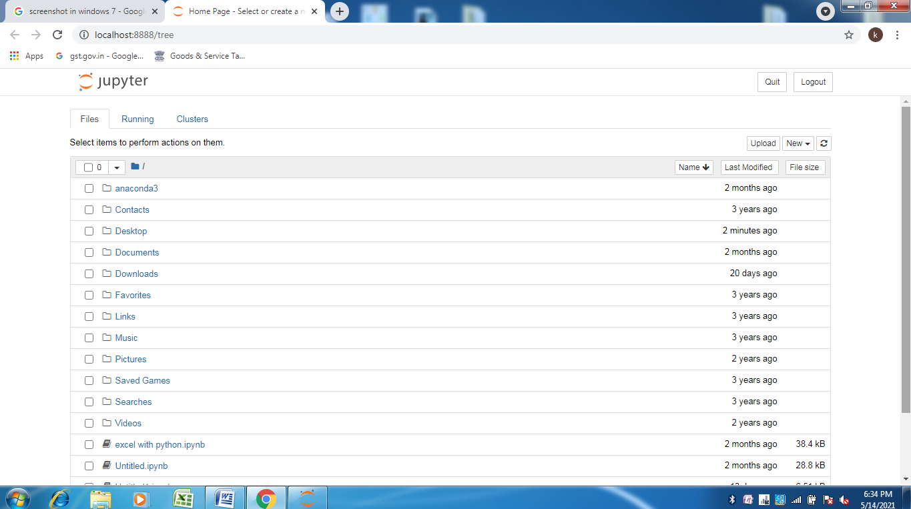

Scroll down and you will find “[write gst details to excel.ipynb](http://localhost:8888/notebooks/write%20gst%20details%20to%20excel.ipynb)” file click on it

The file will get opened and you can see the code.

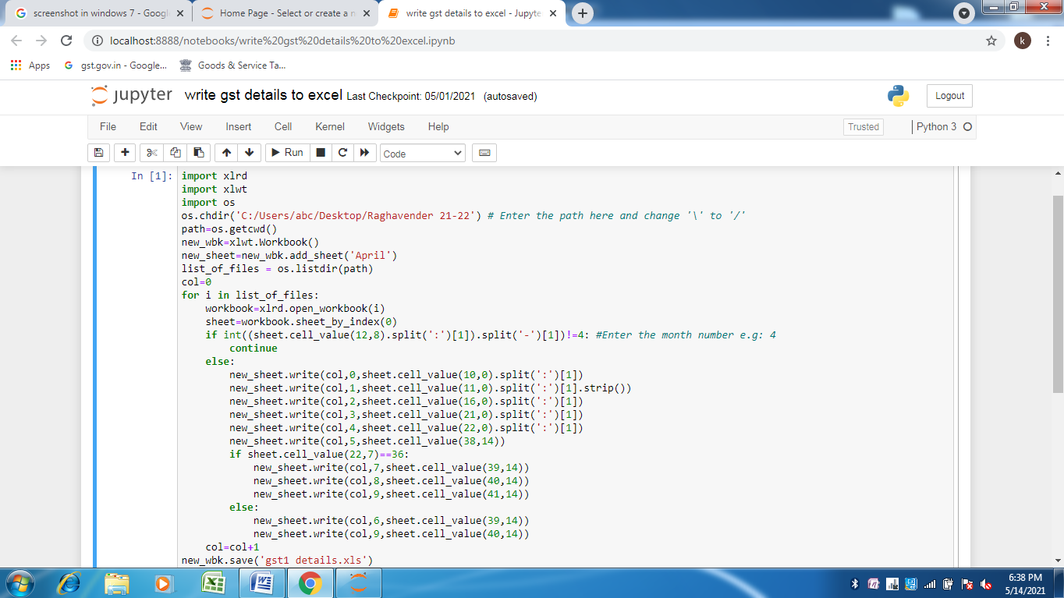

In this code we have change the path which is fourth line.

We should enter the path of the folder where bills are placed

## GETTING PATH FROM FOLDER.

Open the folder and press on top you can see the path press CTRL+C to copy the path, here the path is “C:\Users\abc\Desktop\Raghavender 21-22”.

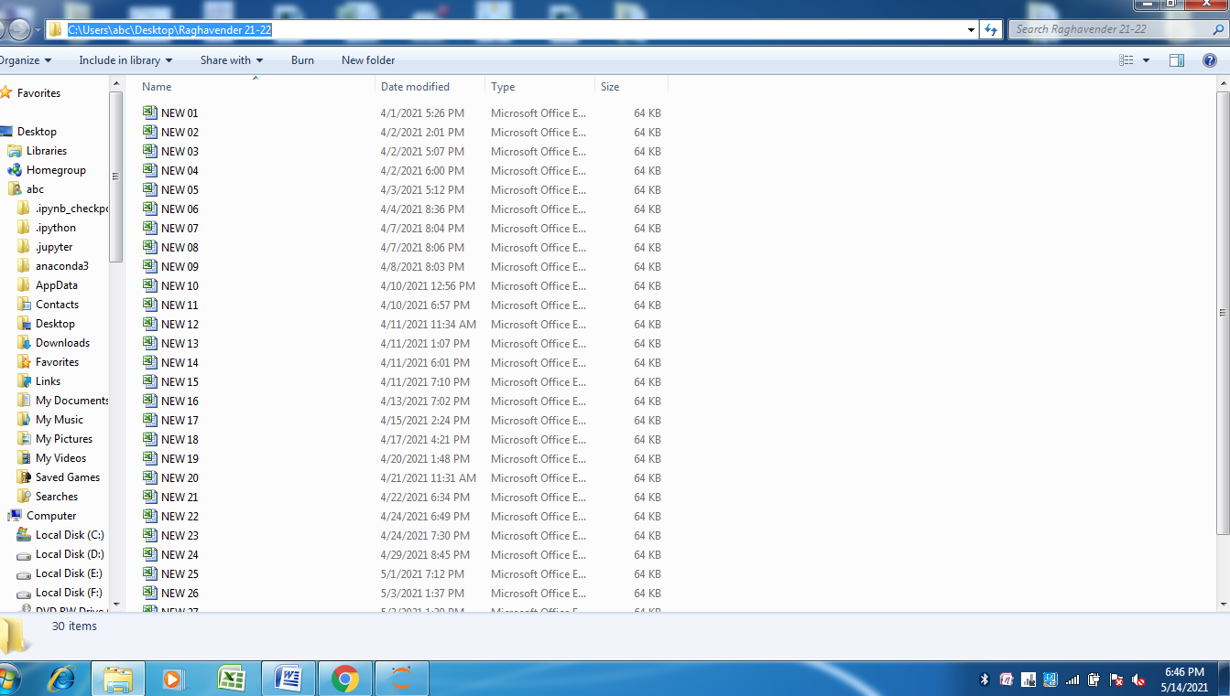

Now move back to code…

## PLACE PATH AND MONTH NUMBER.

In the fourth line of code paste the path as shown below.

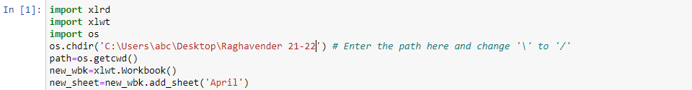

Here change the ‘\’ with ‘/’ just as shown below.

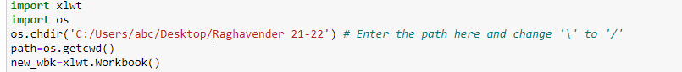

Now move down to place where we have to enter MONTH NUMBER.

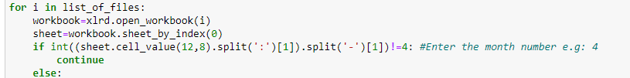

NOW PRESS **SHIFT+ENTER** TO RUN THE SCRIPT

You’ll find the excel “gst1 details” in the Raghavendra folder…

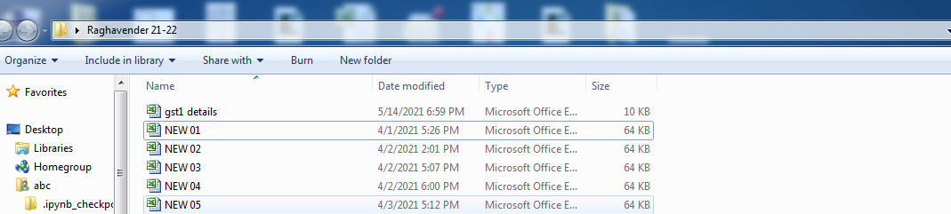

# FORMATTING EXCEL FILE.

Open the excel file press CTRL+A then in HOME🡪FORMAT🡪select ROW HEIGHT

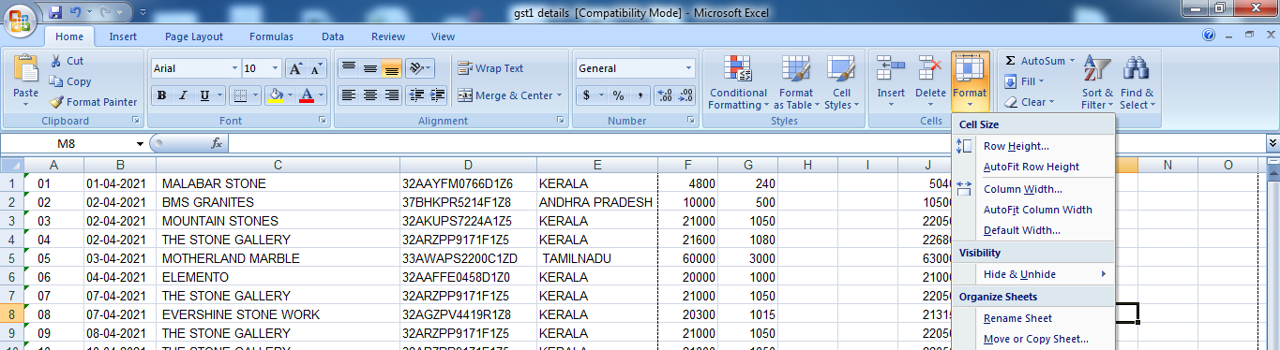

Enter ROW HEIGHT as 15 to make it comfortable

.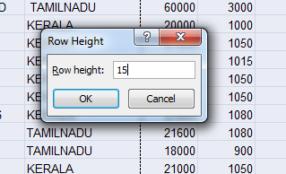

To add borders press CTRL+A and then click twelveth.PNG and select **ALL BORDERS**

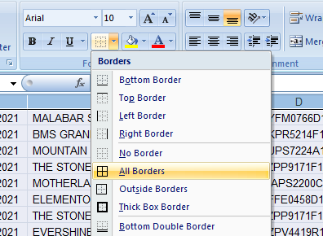

Excel will be added with borders.

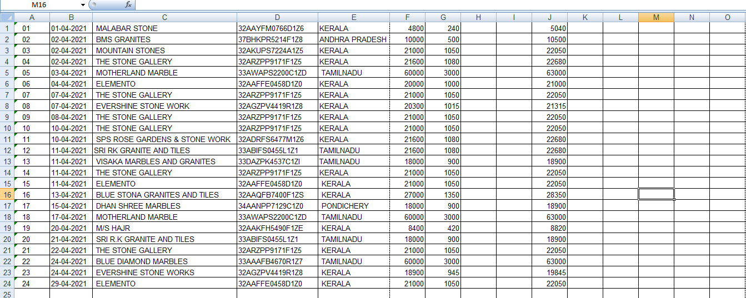

To get the total amount press =SUM(F1:F24), =SUM(G1:G24) and =SUM(J1:J24) to get the total amount.

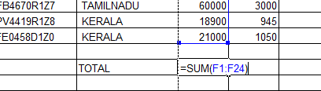

## PRINT IN LANDSCAPE MODE.

Go to print preview

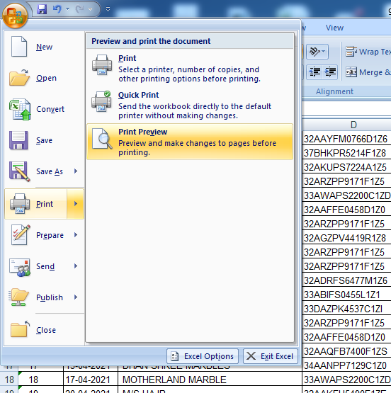

Click on PAGE SETUP

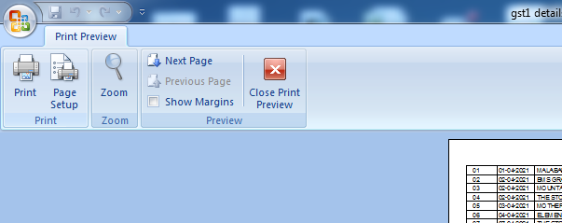

Then click on Landscape mode

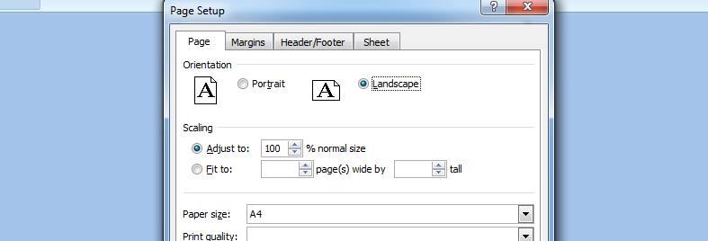

Press “OK” and then Print.